National Society of Professional Surveyors

CERTIFICATE OF PARTICIPATION

Is hereby presented to

In recognition of your participation in the

TRIG-STAR COMPETITION
2022-2023

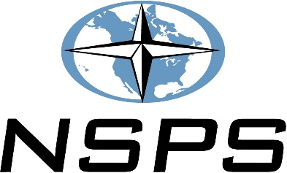

____________________________________________
Trigonometry Teacher

_______________________________________________________
Local Sponsor

